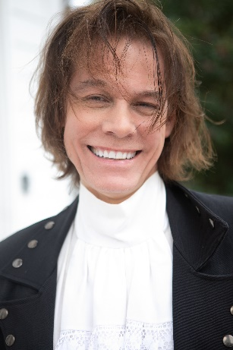
William Glenn Christopher
803 727 8237
wilchristopher10@gmail.com
PO Box 145 Carlisle, SC 29031
5’10” / 150 lbs
williamglennchristopher.com

Film
Pater Noster (2024 Release) Supporting Films Colacitta
Practical Pirate Supporting Alex Davis Independent Films
Righteous Gemstones Background S2 & S3 & Xmas Promo Close-up
The Eyes of Tammy Faye Background Phone Bank Dir. & Studio Dir.

Voiceover
Senior Week (1987) Wrote/voiced radio segment Goldman Productions

Theater
The Town That Time Forgot Old Guy Union Little Theater
Dream Girls Jerry Town Theater
Tea and Sympathy Chorus Spartanburg Little Theater
You Can’t Take It With You Tony Union Little Theater
Rosencrantz and Guildenstern Player #1 College
The Mad Show A Player College
The Wizard of Oz Scarecrow Upstate Community Theater
Shakespeare various scenes studied College

Training
BA in Fine Arts, Theatre (professor studied under a professor who studied with Stanislavski)
Drama, Inc. Atlanta, Hagen Method & Film Fundamentals 2023
SACC Training Workshops / Charleston, SC, 2021–Present
Cindy Hogan (Atlanta) Film Acting Classes & Workshops & Coaching, 2021-Present
Chad Darnell & Matthew Safick Film Study Workshops (Casting Directors)

Skills
Classically trained pianist/currently singer/songwriter performer, band musician/local standup comedy
Career as announcer, journalist, Edward R. Murrow Award Recipient, talk show host, drive-time deejay
Firearms, courtroom, political rallies, subcommittee hearings, activist speaker, horses, martial arts

Accents
Quick study on any accent, Various US, Southern, Various English, French, German, Italian

